Introducing Mindworks Surrey – the new name for Surrey’s emotional wellbeing and mental health service for children and young people

The alliance of organisations working together to deliver the new emotional wellbeing and mental health service for children and young people in Surrey, is delighted to announce the new service name:

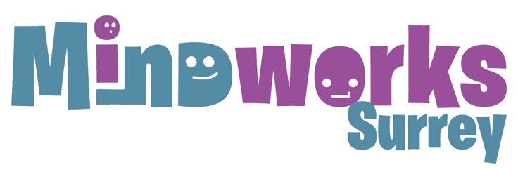
The name, and its vibrant branding, has been co-produced with children and young people alongside families, carers, schools, GPs, and alliance staff. The Mindworks Surrey team love that the logo feels positive, upbeat, and reflects different emotions which children and young people can feel. The ‘i’ in Mindworks is deliberately accentuated as, with this new service, the main emphasis is on giving children and young people a central voice in decisions about their care.
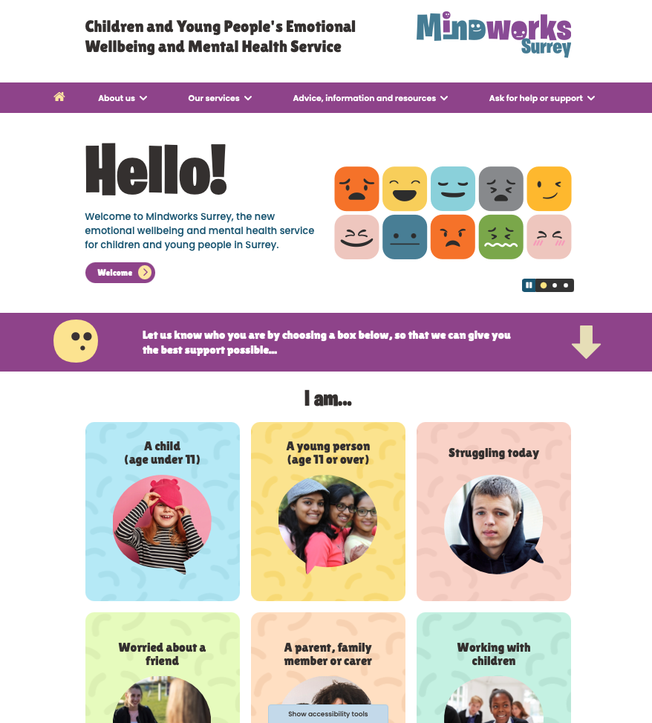
Mindworks Surrey also has a brand new website: www.mindworks-surrey.org providing children, young people, families and carers with information about services, advice and resources. It is a source of essential information, including how to ask for help in a crisis via the 24/7 Crisis Line.

It features a dedicated area for professionals including schools and GPs. Please take a look at the website and come back to it regularly. Please also mention it during meetings and appointments with children, young people and families.

Thanks to everyone who gave up their time to help co-develop the new name and website.

