Graded Care Profile 2:
Principles and Frequently Asked Questions

Surrey Safeguarding Children Partnership has adopted the Graded Care Profile 2 (GCP2) tool to assess the quality of care a child is receiving where there is known or suspected neglect. This list of Frequently Asked Questions intends to address the queries practitioners may have about using the GCP2.
GCP2 Principles in Surrey
- GCP2 supports timely assessment/intervention in known or suspected neglect cases backed up with ongoing and sound professional judgement and multi-agency collaboration.
- Where neglect is known/suspected, GCP2 should be used across the multiagency partnership, including to support referrals to other agencies and to the Children’s Single Point of Access (C-SPA).
- Where immediate referral or immediate action is required, practitioners may not have had the opportunity to undertake the GCP2 and not having a GCP2 should not preclude a referral being made/accepted.
- GCP2 and its contents should be discussed in supervision to ensure sound professional judgements are supported in cases of known/suspected neglect.
- GCP2 can be repeated to monitor progress in parental care given and to support ongoing interventions. Where a stagnation or decline in care is evidenced, this can support practitioners’ decision making to escalate their concerns.
- GCP2 can be undertaken by an individual practitioner or by a group of practitioners working together.
- Explicit parental consent is required to undertake the GCP2 where the threshold of significant harm has not been met.

Frequently Asked Questions

What is the Graded Care Profile 2?
The Graded Care Profile 2 (GCP2) is a strengths-based assessment tool that measures the quality of care being given to a child, helping practitioners to identify neglect and put in place support and interventions to address areas of concern.
The GCP2 is designed to provide an objective measure of the care of children and is based on the qualitative measure of the commitment shown by parents or carers in meeting their children’s developmental needs.
The GCP2 is a licensed tool from the NSPCC.

What are the differences between the original GCP and the new GCP2?
The GCP2 has built on the NSPCC’s evaluation of the GCP and is therefore an updated version. The core concept, design and structure of the original GCP remains as before. Some of the language has been changed to make it more accessible. There are some new areas for assessment such as ‘obesity’ and ‘online safety’. The tool has also been enhanced to make it easier to understand and use. The updated version of the tool has been tested for reliability and validity.

What does the GCP2 measure?
The GPC2 measures the quality of care given to an individual child over a short window of time (i.e. it represents the current level of care). The care given is graded between 1 (most positive) and 5 (most negative) in all areas of a child’s needs, and these scores have an accompanying Red, Amber, Green rating making it easy to see where there are concerns that need addressing.
The grades are based on the extent to which the needs of the child are currently being met and the commitment of the parent/carer to the child in relation to particular areas of care. The areas of care are based on Maslow’s Hierarchy of Needs (physical care, care of safety, emotional care (love and belonging), and developmental care (care of esteem) which are then further subdivided.
The GCP2 doesn’t explore reasons why a particular level of care is given to a child. However, it encourages further exploration of the reasons at the analysis stage and this is supported by the practitioner’s report and records.

Why do we need GCP2?
Neglect is the most prevalent type of harm affecting around 10% of all children (Radford, L. et al, 2011) and the reason why most children in Surrey, and across the UK, are on child protection plans. It is also a prevalent factor in Child Practice Safeguarding Reviews both locally and nationally, contributing to many children being significantly harmed or killed.
Neglect is:
- Difficult to assess objectively
- Challenging to capture and evidence
- Intergenerational
- Complex and co-existing
- Somewhat subjective and open to bias
- Subject to high thresholds for recognition
To try and address this, Surrey are implementing tools across the partnership to support the assessment, interventions and response to concerns regarding neglect and the quality of parenting provided to children.

Who can use GCP2?
Any practitioner who understands child development and safeguarding, who has access to work with families and who has completed GCP2 training. This includes (but not limited to) colleagues from:
- Health visiting
- School nursing
- Family Centres
- Family Support Programme
- Family Safeguarding
- Targeted Youth Services
- Children with Disabilities Teams
- Safeguarding Adolescents Teams
- Home Link Workers in schools
- Designated Safeguarding Leads in schools
- Inclusion Teams
- Voluntary sector partners

Isn’t this just a tool for social workers?
As stated in Working Together to Safeguard Children (2018), safeguarding children is everyone’s business. We know that supporting children and families as early as possible is key to children being safe, happy and well in the long term. Therefore, it is important that GCP2 is adopted as a universal tool and used by practitioners delivering services across all levels of the Effective Family Resilience Model (see below). By using GCP2 with families as soon as concerns are identified about the quality of care a child is receiving, practitioners may be able to help the family to be more resilient and prevent the child/ren from experiencing harm.
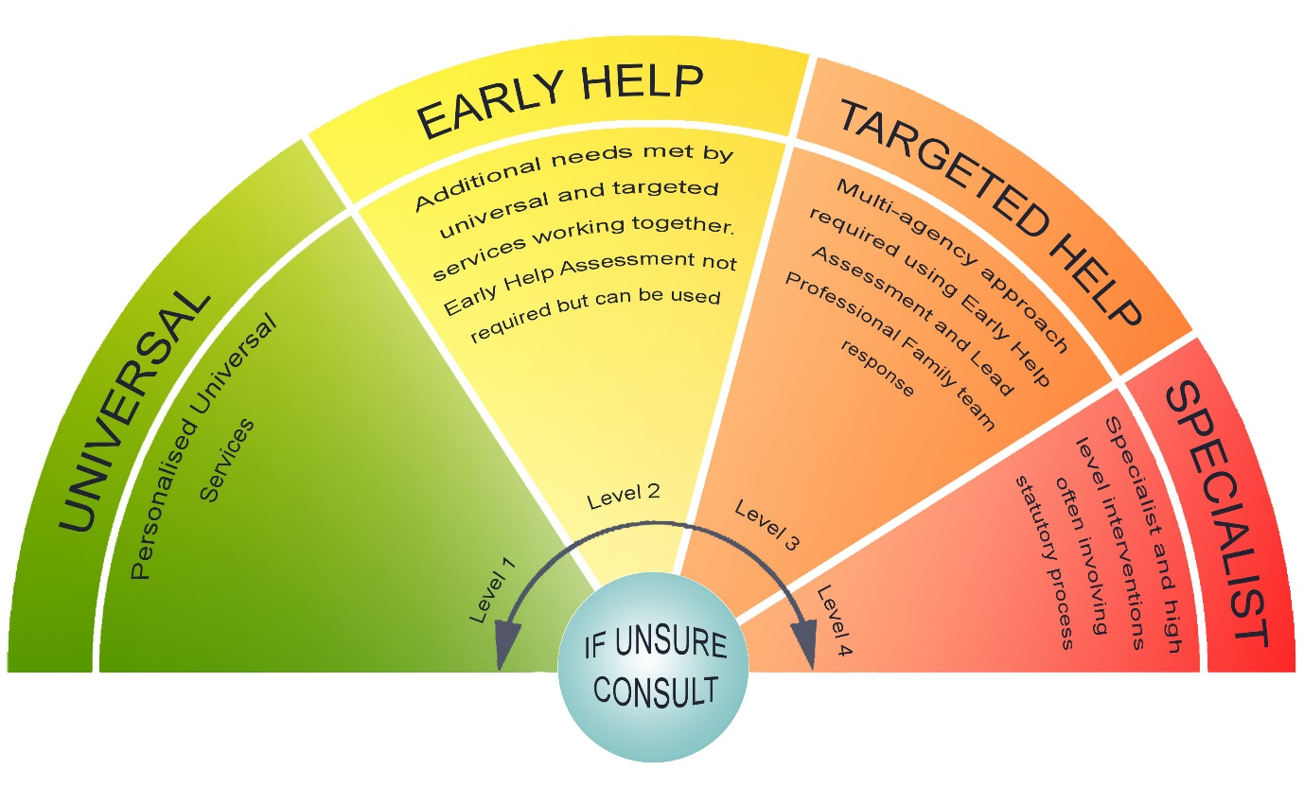(Surrey Safeguarding Children Partnership)

I have used the previous (older) version of the GCP tool – so can I now use this new version of the GCP2?
No. The updated GCP2 is now a licenced tool. The Local Authority area that the practitioner is working in has to be licenced for its staff to use the tool. Also, every practitioner in the licenced Local Authority area that uses the tool has to be accredited. Accreditation is achieved by undertaking an assessed one-day training course provided by SSCP. Therefore, unless a practitioner has completed the training and been satisfactorily assessed by the trainers, it is not possible for them to use the GCP2

I have not received training in the new GCP2 but want to use GCP2 with a family. What should I do?
Unfortunately, unless a practitioner has attended training and been successfully assessed during the training, it is not possible for them to use the GCP2 tool. However, there are several ways forward to enable practitioners to use the GCP2:
- We have planned many GCP2 training courses for practitioners from across the whole partnership to access, so look up the dates for this training and book your space. You will need to attend the whole course from start to finish, have your line manager’s permission and commit to utilising the GCP2 with families when neglect has been identified as a concern.
- If you know a colleague from within your own agency or another agency who is licenced to use the GCP2, then co-work with them to complete the assessment. This is an excellent way of becoming familiar with using the tool.

I have completed the GCP2 training and I am now accredited to use the GCP2. How do I now get access to copies of the GCP2 tool and the accompanying materials?
If you have done the GCP2 training, your trainers will have supplied you with electronic or hard copies of the GCP2 materials. Copies of these are also available to you via the GCP2 Team on Microsoft Teams. If you need support with accessing copies please contact; Alex Dave, alex.dave@surreycc.gov.uk

Which practitioner working with a family should undertake the GCP2?
Only those who have received the GCP2 training and been assessed as competent to undertake assessments using the GCP2 can use the tool. However once trained, any accredited practitioner can use the tool in circumstances where neglect is known or is suspected. Where there is a multi-agency group of practitioners working with a family, e.g. a Team Around the Family or a Core Group, those practitioners may wish to explore who is best placed to use the GCP2 tool, usually the Lead Practitioner. Equally professionals could do the GCP2 assessment together, either co-working the whole assessment or dividing up the assessment between practitioners.

What are the circumstances for using the GCP2 in Surrey?
- In any agency where there is an ‘open case’ of suspected/known neglect. This includes in any part of the agency’s system e.g. a Looked After Child, Children with Disabilities etc.
- Where a referral about known/suspected neglect is being made to C-SPA by any agency. In this instance as and far as possible, a completed GCP2 should accompany the Request for Support form (referral) or be underway.
- Child Protection Conferences where a child/young person:
  - is placed on a Child Protection Plan under the category of neglect
  - is placed on a Child Protection Plan under a different category but where neglect is known/suspected
  - has not had a completed GCP2 done for known/suspected neglect in previous 3 months

Do Parents have to provide consent for a GCP2 to be completed?
Yes. Where parents do not consent, this should be noted and contribute to the ongoing assessment/analysis of the child’s circumstances and safety.

Can the GCP2 be done retrospectively?
No. The GCP2 is used to measure and assess the current care being given to a child. It is important to record the dates during which the GCP2 is completed because it is recognised that care can fluctuate over time. Clarifying the current level of care means that when the scoring is repeated, it can provide evidence about whether there have been improvements or deterioration in the level of care for a child.

Can I use one GCP2 for more than one child?
It is intended that each child in the family has their own GCP2 assessment undertaken. This recognises that different children in the same family are at different ages and stages of development and therefore the care that parents/carers need to provide to them will need to be different. Even where children are at very similar age and stage, parents/carers may provide differing types of care to each child.
However, it is possible for assessments and sections for more than one child in a family to be undertaken at the same time, e.g. when an observation of the parent offering care to all their children is being undertaken. Or where the care is observed to be the same for each child, the same information may be used across different GCP2s.

Can I undertake some parts of the GCP2 and not others?
The GCP2 measures care given to a child across the whole continuum of a child’s needs. It is this that supports effective planning and interventions, so practitioners are clear where the strengths and concerns are in the care given.
As such the whole of the GCP2 should be undertaken to ensure there is a clear and balanced view about how children’s needs are being met.
Naturally if there are aspects which are not relevant for a particular parent or child, then that area should be left out.
Sometimes a practitioner will only be able to contribute to one or a few parts of the tool and it is important that they can contribute their knowledge to the completion of the tool. Then other agencies can contribute to other areas of the tool more relevant to them and their role with the family.

What are the timescales for using the GCP2 tool?
Because care of children can fluctuate over time and to avoid results being distorted the GCP2 should be undertaken over several sessions. It is difficult to pinpoint the exact number of sessions because each family situation will be very different. As a guide, where there is a parent/carer who is engaged with the GCP2 assessment and is able to explore matters in a relatively straightforward way, a GCP2 could take about 3-4 sessions, lasting about 1 hour each. Naturally additional time may be needed if a situation is more complex. These sessions should take place within the maximum window of 4 weeks to ensure the GCP2 is a ‘snap shot’ in time/
The GCP2 should be repeated within approximately 3-6 months after completion, to see if any progress has been made with child’s care.

I completed GCP2 training outside of Surrey, do I need to complete the training again?
No. As long as you can provide certification to evidence that you have completed the course, you do not need to complete the course again. Where this is the case, please speak to Surrey Children’s Services Academy- surreychildrens.academy@surreycc.gov.uk.

What if I don’t have enough time to complete the GCP2 or I don’t work with parents/carers?
SSCP has developed a briefer Neglect Screening Tool for practitioners who have time-limited contact with children and families. This tool supports practitioners who are not able to complete a GCP2, to identify signs of neglect at an early stage and to help them to discuss concerns with their Manager or Safeguarding Lead, in order to decide the next appropriate steps. This tool can be downloaded from the SSCP website.

Where can I go to for any additional questions about using the GCP2?
The SSCP website contains information and resources about the GCP2 project as well as information about how to access training.
Surrey also has over 20 GCP2 Champions across health, education, children’s services and the voluntary sector who are helping to deliver GCP2 training and to embed GCP2 in to practice. Please speak to the GCP2 Project Manager to find out who the GCP2 Champions are in your area of work.
Alex Dave, GCP2 Project Manager, alex.dave@surreycc.gov.uk

