Children’s Guide for Child Protection Conference

What is a Child Protection Conference?

What will happen?
Who will be there?

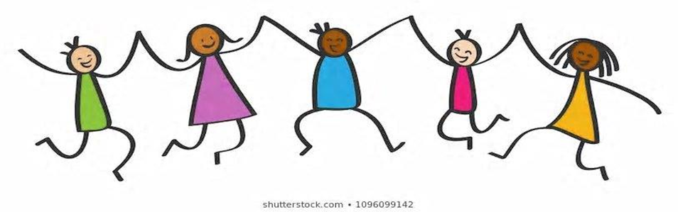
What is a Child Protection Conference?
A Child Protection Conference is a special
Meeting that is held if people have a worry about how things are for you and your family. They will talk about what they can do to help keep you safe.

- What happens at the meeting?
In the meeting they will talk about:
- What is happening for you and your family.
- What problems you and your family might be having.
- What helps to make you feel safe and how we can find ways to do more of this.
- Finding the best ways to keep you safe and help your family.
Who will be at the meeting?
You may know some but perhaps not all those that go to the meeting. They will all be people wanting to make your future safer. These may include:
- Someone to organise the meeting
- Your parents
- Your social worker
- Someone from your school
- A doctor or nurse
- A health visitor
- A police officer
- Other people who have met and worked with you or your parents

Can I have my say?
We would like you to take part. You can do this by…
- Talking to someone who is going to the meeting
- Writing something down about how you feel and giving it to your social worker
- Drawing a picture and give it to your social worker to show at the meeting

