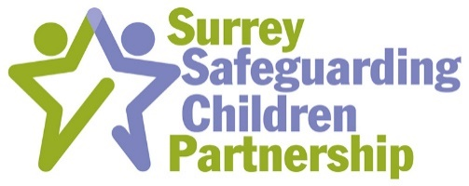
Probable Suicide by Children and Young People in Surrey
Thematic Review Learning Event
5th and 13th October (9.45 arrival) 10:00 – 12:00 and (13:45 arrival) 14:00 – 16:00
Microsoft Teams
Learning outcomes from the day:
Aim: For Surrey Safeguarding Children’s Partnership to support the dissemination of lessons identified in the thematic review through a learning event.
By the end of the day, participants will have an updated knowledge of:
- The learning and themes identified in the thematic review
- How a Surrey Healthy Schools approach supports schools in assisting children and young people to develop skills that build emotional resilience
- The experience of a local school in responding to a probable suicide by a pupil
- The role of CAMHS in supporting staff working with children at risk of suicide
- What actions organisations across Surrey will be taking to support children and young people at risk of suicide
Programme
Time | Topic | Speaker | Key public health domain
9.45 | Arrival
10.00 | Introduction | Simon Hart, Independent Scrutineer, SSCP | Strategic leadership and collaborative working for health
10.05 | Quiz – what do you know about suicide and children and young people | Noreen Gurner-Smith, Safeguarding Manager with Lead for Child Death Review Services, Surrey Heartlands CCG | Develop and maintain your professional performance
10.15 | Results of the thematic review | Nicola Mundy, Child Wellbeing Professional and Lead for Learning from Child Deaths | Use of public health intelligence to survey and assess a population’s health and wellbeing.
10.25 | Surrey Healthy Schools | Sarah Lyles  PSHE & Wellbeing Lead, Surrey CC | Health improvement, determinants of health and health communication
10.45 | Probable suicide in our school. | Local headteachers | Teaching, training, supporting and assessing
11.00 | CAMHS Specialist Services  Getting more help and getting risk support | Dr Phil Ferreira-Lay  Clinical Director & Consultant Child Psychiatrist  Community Child and Adolescent Mental Health Services NE Surrey | Work collaboratively with colleagues to maintain or improve patient care
11.20 | Suicide prevention Toolkit | Noreen Gurner-Smith, Safeguarding Manager with Lead for Child Death Review Services, Surrey Heartlands CCG | Health improvement, determinants of health and health communication.  Develop and maintain your professional performance
11.30 | Small group work on action to be taken by agencies to respond to recommendation in thematic review | Noreen Gurner-Smith, Safeguarding Manager with Lead for Child Death Review Services, Surrey Heartlands CCG  Nicola Mundy, Child Wellbeing Professional and Lead for Learning from Child Deaths  Paul Bailey, Partnership Development Manager, Surrey Safeguarding Children Partnership, Surrey County Council  Sarah Lyles  PSHE & Wellbeing Lead, Surrey CC | Communication, partnership and teamwork. Work in, and manage, partnerships  and teams effectively and with due consideration of others.
11.50 | Feedback | Noreen Gurner-Smith, Safeguarding Manager with Lead for Child Death Review Services, Surrey Heartlands CCG | Communication, partnership and teamwork. Work in, and manage, partnerships  and teams effectively and with due consideration of others.
12:00 | Close

