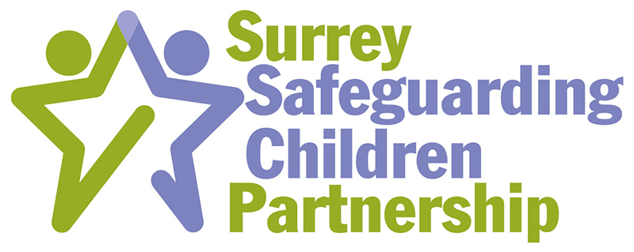

“Working Together to Safeguard Children and Young People”
Exemptions

Those staff who have regular contact with or have a period of intense but irregular contact with children, young people and/or their parents/carers, and who may be in a position to identify concerns about maltreatment, including those that may arise from the use of Early Help Assessment, should complete Working Together to Safeguard Children induction training.

There are exemptions to this, these are:

- Evidence that they have completed the Children Workforce Development Council (CWDC) module 6 safeguarding training and have regularly updated this training every three years with a safeguarding refresher course.
- Evidence that they have completed the What To Do If induction course and have regularly updated this training every three years with a safeguarding refresher course.
- Evidence that they have completed an alternative safeguarding induction course which meets the following criteria.
- A line manager provides evidence to the agency safeguarding lead/DSL/designated lead, that the member of staff successfully meets the following criteria.

Name of Induction Training: Training Organisation:
Requirement Criteria | Y/N | Date
Knows about laws and national guidance relating to protecting children
Can describe workplace’s policies and procedures on helping children
and young people who have been abused
Understands what children and young people want and need to feel safe
Has an awareness of what contributes towards a safe environment for the children and young people they work with
Understands the different ways in which children and young people can be harmed by adults, other children and young people, or through the Internet
Understands what is meant by: physical abuse, sexual abuse, emotional abuse, domestic abuse, faltering growth, institutional abuse, bullying and self-harm
Can describe signs and indicators of possible abuse and neglect
Can describe the procedure to follow if they suspect any child is being abused, neglected or bullied
Understands that parental problems (for example, domestic abuse, drug and alcohol abuse, mental ill health) can increase the risk of harm to a child
Can describe what emergency action needs to be taken to protect a

child, including outside normal office hours
Understands what ‘multi-agency working’ means
Understands other agencies’ roles and responsibilities in keeping
children safe from harm
Knows about the Surrey Safeguarding Children Board and any role their agency, organisation or employer has on it
Knows when and how to refer a concern about child protection
Can explain whom to consult in relation to a child protection or child- welfare concern
Understands their duty to report the unsafe practice of others
Knows what to do if they have followed their own workplace’s policies and procedures on reporting concerns, and are not satisfied with the response
Can identify what to do if they do not get a satisfactory response from other organisation or agencies

Member of Staff: Date:
Email:

Line Manager: Date:
Email: Safeguarding Lead: Date:
Email:

Submit this form to the Surrey Children’s Services Academy Training Team for approval at sscb.training@surreycc.gov.uk

Signed on behalf of the SCSA: Date:
Once countersigned by the SCSA, you will be emailed a copy of this form.
Please keep this with your professional development records.

