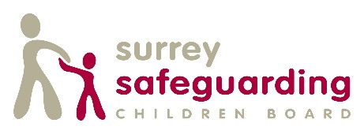
Learning agreement for delegates attending SSCB multiagency safeguarding training.

At the point of enrolling on SSCB multi agency training you are asked to agree to the following principles:
- I have discussed this training/workshop with my manager, who is satisfied that this is relevant to my role and has given me permission to attend.
- I will value and listen to contributions.
- I will value and respect difference.
- I agree to take an active participative role in the learning event.
- I will be respectful to everyone in the group and will challenge and question in a way which is constructive and enabling to the training objectives.
- I agree to complete the training/workshop in full. I understand that if do not do this I will not be given a certificate of attendance.
- I will arrive in good time for the course start. Anyone who arrives in excess of 30 minutes late may be turned away.
- I will take responsibility to reflect on learning and embed it within my practice including sharing learning and good practice with colleagues
- I will complete pre and post training forms on line which will include the evaluation of my learning needs, an action plan following training, learning achieved and the impact of learning on practice.
- I will discuss outcomes of learning in supervision with my line manager
- The impact of learning will be discussed in every appraisal, as part of the annual cycle, to determine if the learning has assisted in developing relevant knowledge and skills. (What have you done to ensure you are up to date with current changes around safeguarding and how does your practice evidence this? How has this learning impacted on outcomes for children and families?)
- I will take responsibility for my development and make relevant improvements to my practice and ability to safeguard children.
- I will be responsible for my own training records and monitoring, and will provide my employer with any certification of training attendance provided by SSCB.
- Different points of view should be welcomed, but everyone has the responsibility to draw attention to remarks that show a lack of respect to diversity or are offensive in anyway, even if unintentionally.
- I agree that the contributions and feelings of participants expressed as part of the course may be used as part of the assessment process but should otherwise be confidential to the group.

