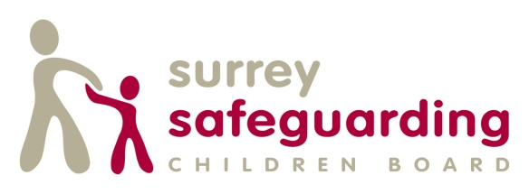

Child Exploitation Multi-agency Training Pathway

Child Exploitation (CE) is a key priority for the Surrey Safeguarding Children Board.
Child Criminal Exploitation occurs where an individual or group takes advantage of an imbalance of power to coerce, control, manipulate or deceive a child or young person under the age of 18 into any criminal activity (a) in exchange for something the victim needs or wants, and/or (b) for the financial or other advantage of the perpetrator or facilitator and/or (c) through violence or the threat of violence. The victim may have been criminally exploited even if the activity appears consensual. Child Criminal Exploitation does not always involve physical contact; it can also occur through the use of technology.

Child exploitation is a factor in the following:
- Gangs and County lines
- Grooming and sexual exploitation (including Online)
- Child trafficking
- Modern day slavery
- Radicalisation and extremism (Prevent duty to report)
- Peer on peer abuse (unhealthy relationships)
- Children who go missing (from school and home)

Child exploitation can occur through use of technology without the child’s immediate recognition, for example the persuasion to post sexual images on the internet/mobile phones with no immediate payment or gain. In all cases those exploiting the child/young person have power over them by virtue of their age, gender, intellect, physical strength and /or economic or other resources.

County lines is a term used to describe gangs and organised criminal networks involved in exporting illegal drugs into one or more importing areas [within the UK], using dedicated mobile phone lines or other form of “deal line”. They are likely to exploit children and vulnerable adults to move [and store] the drugs and money and they will often use coercion, intimidation, violence (including sexual violence) and weapons.

The Prevent Duty for England and Wales (2015) under section 26 of the Counter-Terrorism and Security Act 2015 places a duty to have due regard to the need to prevent people from being drawn into terrorism. Extremism is defined as ‘as ‘vocal or active opposition to fundamental British values, including democracy, the rule of law, individual liberty and mutual respect and tolerance of different faiths and beliefs.’
Some children are at risk of being radicalised; adopting beliefs and engaging in activities which are harmful, criminal or dangerous. This can happen both online and offline.

We have produced a training pathway to ensure that everyone is aware of CE and that all those working with children and young people are able to recognise and respond appropriately to ensure the safety and protection of children and young people at risk from or experiencing CE.

SSCB has developed a screening tool which all professional groups will use when they have concerns. Following receipt of referral an assessment by Surrey Children’s Services may then be undertaken by a Social Worker.

Level 1 Child Exploitation E-learning (Basic Awareness)
This training is for all staff working directly or indirectly in any capacity with children and young people. This must be completed before level 2 training.

This e-learning course aims to improve awareness and understanding of CE and the impact on young people. It will help professionals understand and recognise risk factors and ultimately work together effectively focusing on the goal of keeping children safe and meeting their needs. Factors that make some young people more vulnerable to exploitation will be considered.

It can be accessed via the Surrey Skills Academy or through the link on the SSCB web page.

SSCB website

Level 2 Child Exploitation Training (Face to face training)
This training is for professionals who work directly with children, young people and families and must have completed Level 1.

This 1 day course is intended to further increase knowledge and confidence in understanding and identifying indicators of child exploitation. It will help professionals develop an increased understanding of grooming methods and understand factors that make some young people more vulnerable to exploitation. It will enable professionals to identify and explain the levels of risk, be familiar with the Surrey CE screening tool and know how to respond to concerns or disclosures using Surrey referral processes.
Booking is via the online booking system on SSCB website.

SSCB website

Aug 2018

