Children’s Guide for Child Protection Conference

What is a Child Protection Conference?

What will happen?
Who will be there?

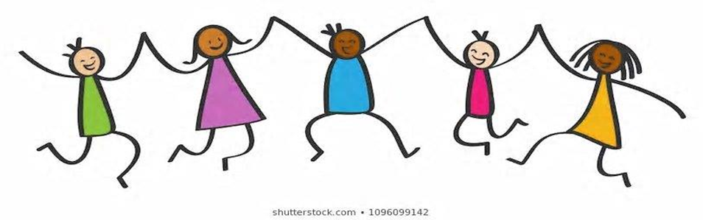
What is a Child Protection Conference?
A Child Protection Conference is a special
meeting if people have a worry about how things
are for you and your family. They will talk about
what they can do to help keep you safe.

- What happens at the meeting?
In the meeting they will talk about:
- What is happening
- For you and your family and why there is a worry.
- What problems you and your family might be having.
- Finding the best ways to keep you safe and help your family.
Who will be at the meeting?
You may know some but perhaps not all those that go to the meeting. They will all be people wanting to make your future safer. These may include:
- Someone to organise the meeting
- Your parents
- Your social worker
- Someone from your school
- A doctor or nurse
- A health visitor
- A police officer
- Other people who have worked with you or your parents

Can I have my say?
- Talk to someone who is going to the meeting
- Try writing something down about how you feel and giving it to your social worker
- Draw a picture and give it to your social worker to show at the meeting

