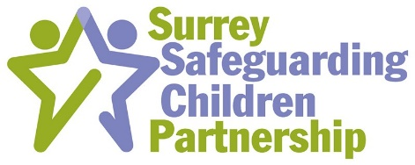
Did you know…according to the Home Office, it’s believed that at least 1 in 10 children experience sexual abuse before their 16th birthday? The Council of Europe's "Start to Talk" campaign highlights that 1 in 5 children in Europe are victims of some form of sexual violence. These statistics demonstrate the need for all who work with children to be able to recognise potential abuse. This includes those involved in sport and other physical activities such as dance and drama.
In partnership with the NWG and the Surrey Safeguarding Children Partnership, we are inviting you to the Official Launch of ‘Safe to Play’ which is an innovative campaign on safeguarding in sport developed by the NWG. NWG is a charitable organisation formed as a UK network of over 14,500 practitioners who disseminate our information down through their services, to professionals working on the issue of child exploitation (CE) and trafficking within the UK.
The event is being held at Surrey Sports Park on Wednesday, 25th May, 2022 at 1030 - 1230. The event, is aimed towards volunteers and coaches within the sporting community, and our safeguarding partners who can help promote this campaign, to equip us all with the tools to identify potential victims of child abuse.

Why you?

Because, not only do all sports clubs have a statutory duty to ensure children are protected from harm, but your close interaction with children and young people, puts you in a pivotal position to identify the warning signs and behaviour that may indicate that a child is being abused. In turn, reporting any information or concerns to the police will contribute to the safeguarding of children.
Extracurricular sports activities have seen a recent boom, with many parents sending their children to sports clubs during the school holidays. While we obviously welcome the rise in activity for children, part of this campaign will be to encourage parents to perform their due diligence before they send their children to these activities, to ensure they are legitimate clubs with the required safeguarding policies, procedures and safe recruitment processes in place. With that in mind, we’re asking sports coaches and clubs to be open about their safeguarding processes when asked by parents – it’s only right that they challenge!

To book the event use the link - Active Surrey Events - Booking by Bookwhen
If you have any further questions please email Lawrie Baker (lawrie.baker@surreycc.gov.uk)

